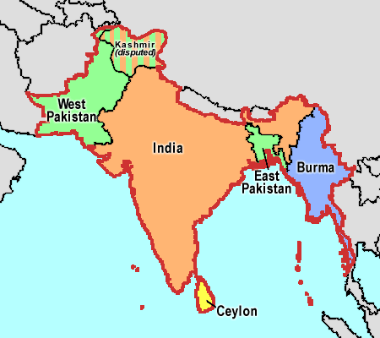
MARY OF MAGDALA ADULT EDUCATION SERIES
SUNDAY MAY 29, 2016 3-4:30 PM ST. PAUL’S EPISCOPAL CHURCH

The Future of God
A DISCUSSION OF DEEPAK CHOPRA’S BOOK FACILITATED BY
REV. STAN MANICKAM

Can God be revived in a skeptical age? What would it take to give people a spiritual life more powerful than anything in the past? Deepak Chopra tackles these issues with eloquence and insight in his book The Future of God: A Practical Approach to Spirituality for Our Times. Chopra invites us on a journey of the spirit, providing a practical path to understanding God and our own place in the universe. Join us for a discussion of Chopra’s book led by Rev. Stan Manickam.

Rev.Stan Manickam is one of six children. He grew up in a devout Roman Catholic family among Hindus and Muslims. He, like everyone else in the community, attended Daily Mass in the morning, daily evening prayers with the parish community in the church, and family rosary at home before supper. “Our daily lives,” says Fr. Stan, “were ruled by the church bell from rising till one went to bed!”
After completing his BS at Loyola College in Chennai, India, he went to Milan and Rome, Italy to complete his licentiate in Philosophy and Theology. After his priestly ordination, he returned to India. He pioneered a new Mission, 60 km South of Chennai.
Rev. Stan has taught in high schools and colleges, and worked as Dean of a business school. Mostly, he has enjoyed working as associate Pastor and Pastor both in India and in the United States. At present he is a part-time chaplain at Halcyon Hospice and Pastor Emeritus at Pax Christi ECC in Denver.

This very special event is open to the public. Fellowship hall will be open at 2:30pm.
Light refreshments will be served. ALL ARE WELCOME!
For more information please call Rosean Amaral, 970-692-4238.

